**CHANGES TO SUPER ADMIN WEBSITE -**

1. The dashboard should show all menu buttons for easy access.

**- Also include -**

- Number of active organizers in india

- Number of active organizers in singapore

- Number of active organizers in usa

- Number of pending organizers

- Number of customers / members

- Number of events active in india

- Number of events active in singapore

- Number of events active in usa 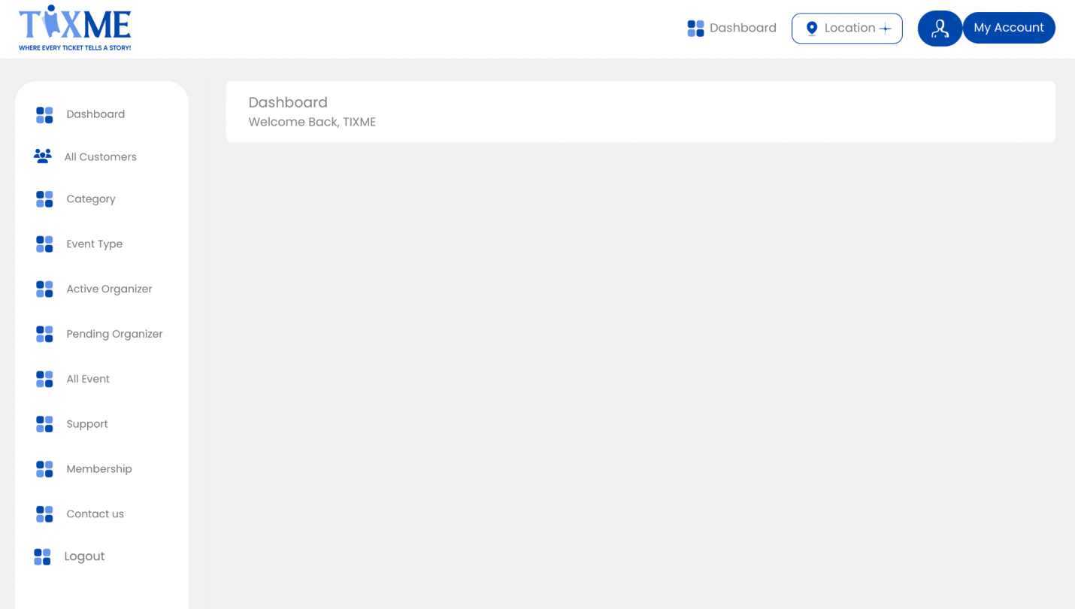

1. We need more details for all customers to be seen -

* Firstly - please arrange this page in lists according to memberships
* For example, when we open customers - we see 4 lists for different memberships

1. Gold
2. Silver
3. Platinum
4. No Membership

* Then we click on these and see the customers under each membership
* We need to see all details of the customers - when we view their account
* We need to see **EVERYTHING about that customer when we click on ‘view’**

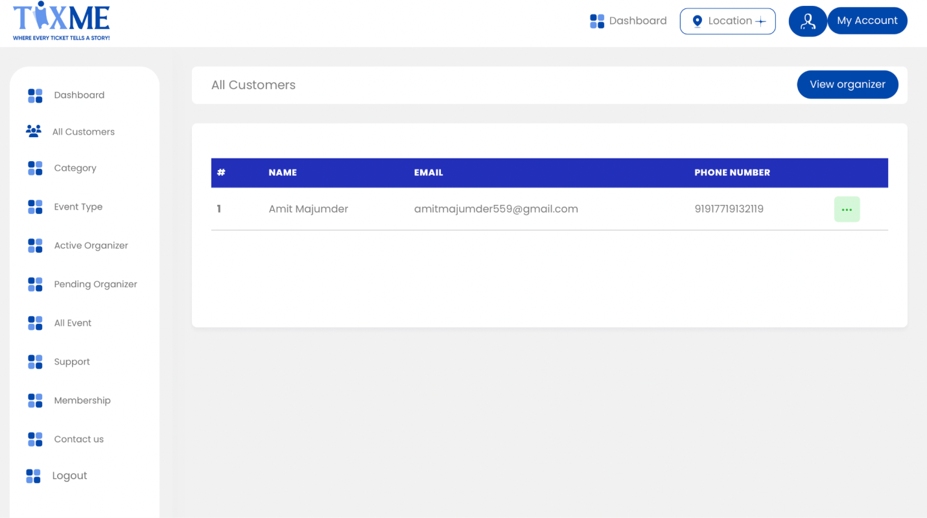

3. We need to see all categories we have sent in this so we only have to “add category” if a new category pops up.

Please have all these categories uploaded beforehand -

1. Day & Night Parties
2. Music & Concerts
3. Business & Networking
4. Sports & Fitness
5. Food & Drink
6. Arts & Theater
7. Festivals & Holidays
8. Bollywood
9. Travel & Outdoor
10. Education & Careers
11. Expos & Exhibitions
12. Conferences & Seminars
13. Fashion & Beauty
14. Film & Media
15. Meet & Greet
16. Technology & Innovation
17. Gaming & eSports
18. Religious & Spiritual
19. Pets & Animals
20. Literary & Books
21. Cultural Fests
22. Home & Garden
23. Hobbies & Interests
24. Health & Wellness
25. Charity & Causes

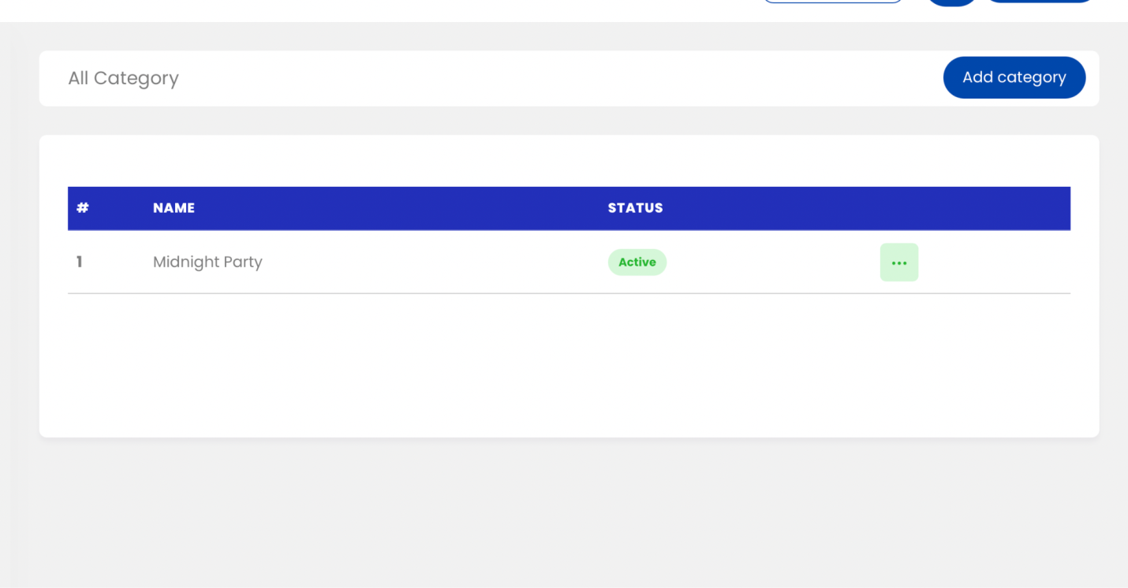

4. This should show total number of online and physical events happening / happened in sections -

1. For online events button - we click on it - we see past / current events option - we click on them - we see list of events with **ALL details of that event (**organizer, tickets sold, venue, payments, and everything else).
2. For physical events button - we click on it - we see past / current events option - we click on them - we see list of events with **ALL details of that event (**organizer, tickets sold, venue, payments, and everything else).

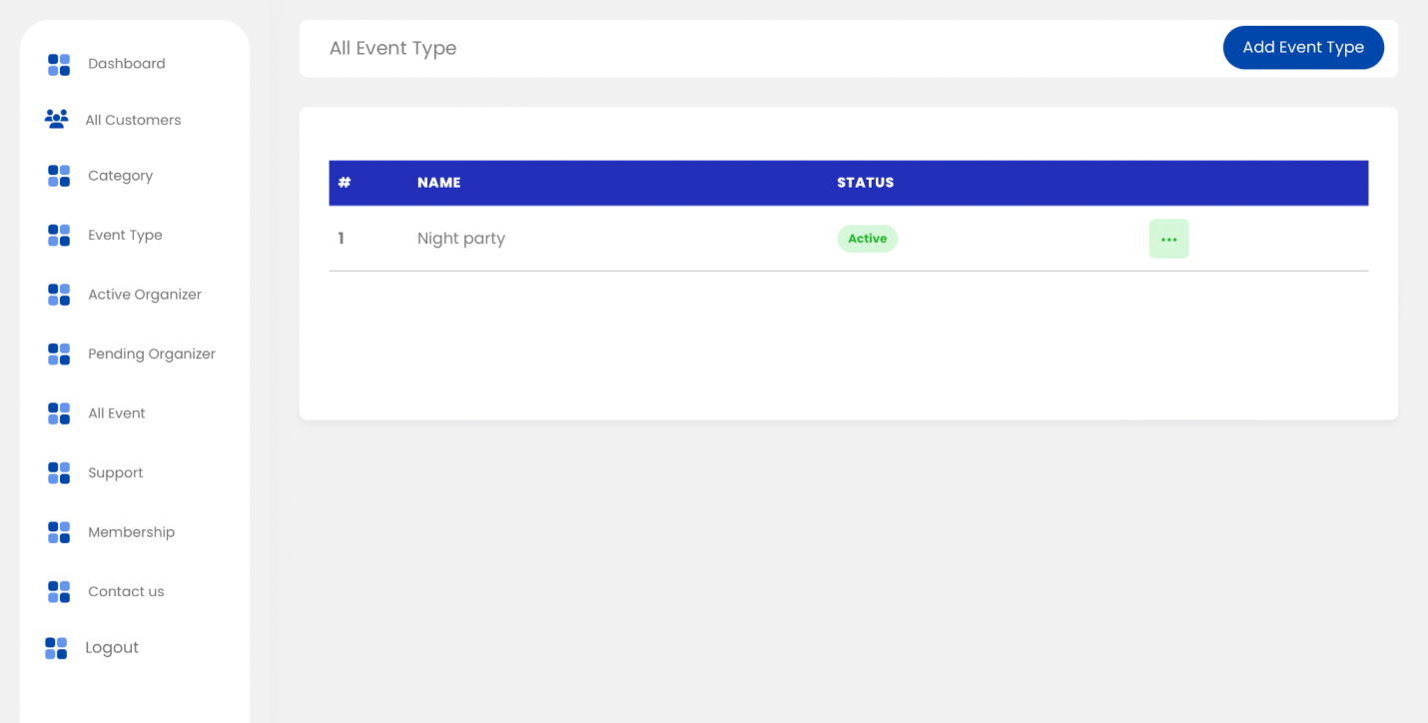

5. Add more details to be seen on this page + fix the ‘view’ button-

We need to see **every detail possible about the organizer.**  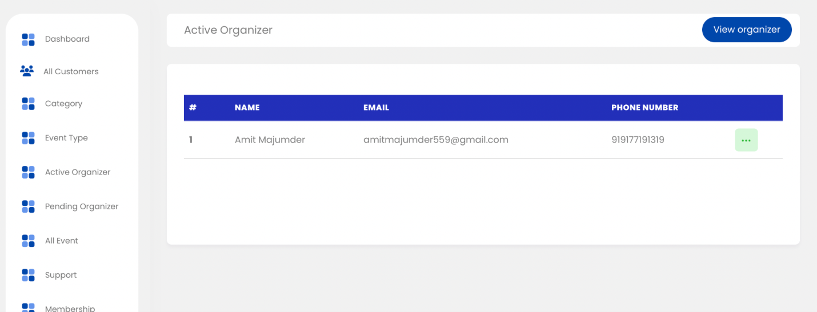

6. Show more details on this page and when we click view - we can see their event request so we can activate them as an organizer on our website. 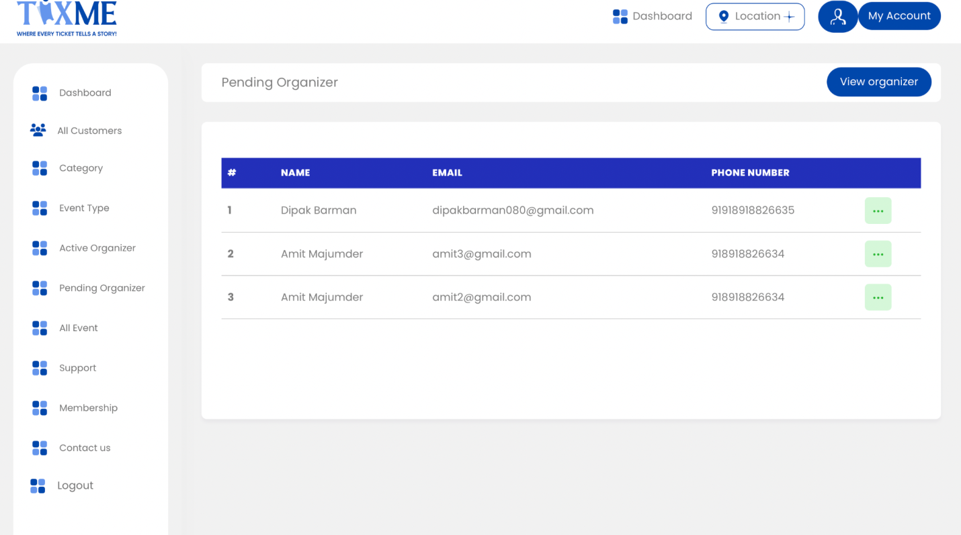

7. We need to see more details here - amount of tickets sold/location/ revenue collected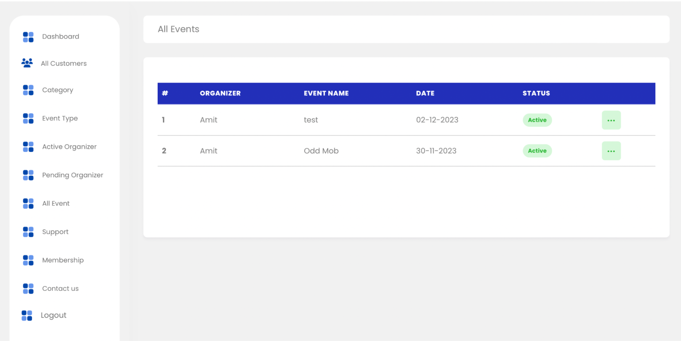

8. Need to see amount of people in each membership so we have a list of their contact details to use mail chimp to send out blast emails. 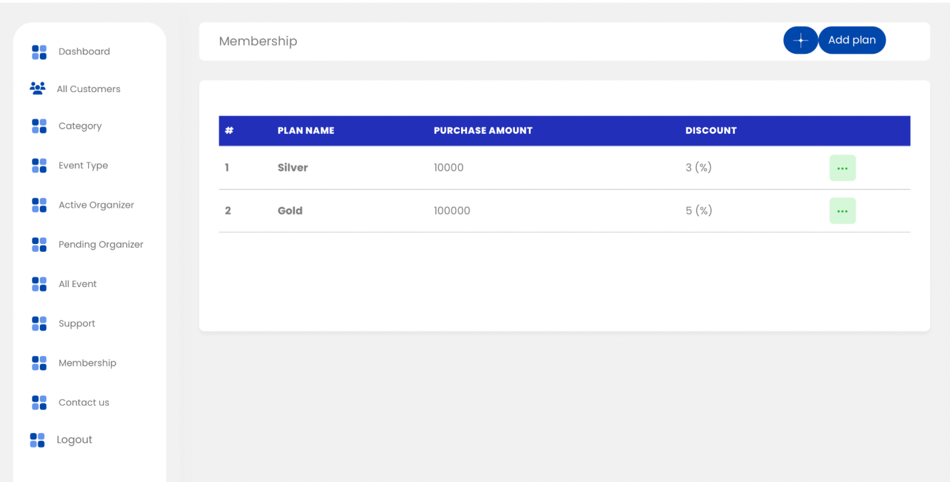

9. There needs to be a submenu about payouts and transactions to account all revenues that have been sent to organizers. - CREATE THIS SEPERATE FOR ALL 3 COUNTRIES